HEALing Communities Quality Measure Databook: Sample Use Cases

**Use Cases:**

1. In Calendar Year 2021, how many members in Erie County have an OUD Diagnosis?
2. In Federal Fiscal Year 2020, what is the percent of members with OUD receiving MOUD in Westchester County?
3. In State Fiscal Year 2021, what is the percent of FFS members with OUD receiving Behavioral Health Treatment (screening)?
4. What is the trend by Coverage Type for Measure 2.6.6: Number of Individuals with OUD receiving behavioral health treatment (peer support) by State Fiscal Year?
5. What is the rate for Measure 4.6.3: Number of Opioid Related Oral Naltrexone Days Supplied for Asian or Pacific Islander Members in Calendar Year 2019?
6. What is the general relationship between Measure 2.4 (Number of Individuals with Opioid Use Disorder (prevalence)) and Measure 2.5.5 (Number of Individuals with Opioid Use Disorder (OUD) Receiving buprenorphine products that are FDA approved for treatment of OUD) in Calendar Year 2021?
7. What is the general relationship between Measure 2.4 (Number of Individuals with Opioid Use Disorder (prevalence)) and Measure 2.5.2 (Number of Individuals with Opioid Use Disorder (OUD) Receiving Methadone) for members ages 18 and up in Calendar Year 2021?
8. In Calendar Year 2021, how many members in Erie County have an OUD Diagnosis?

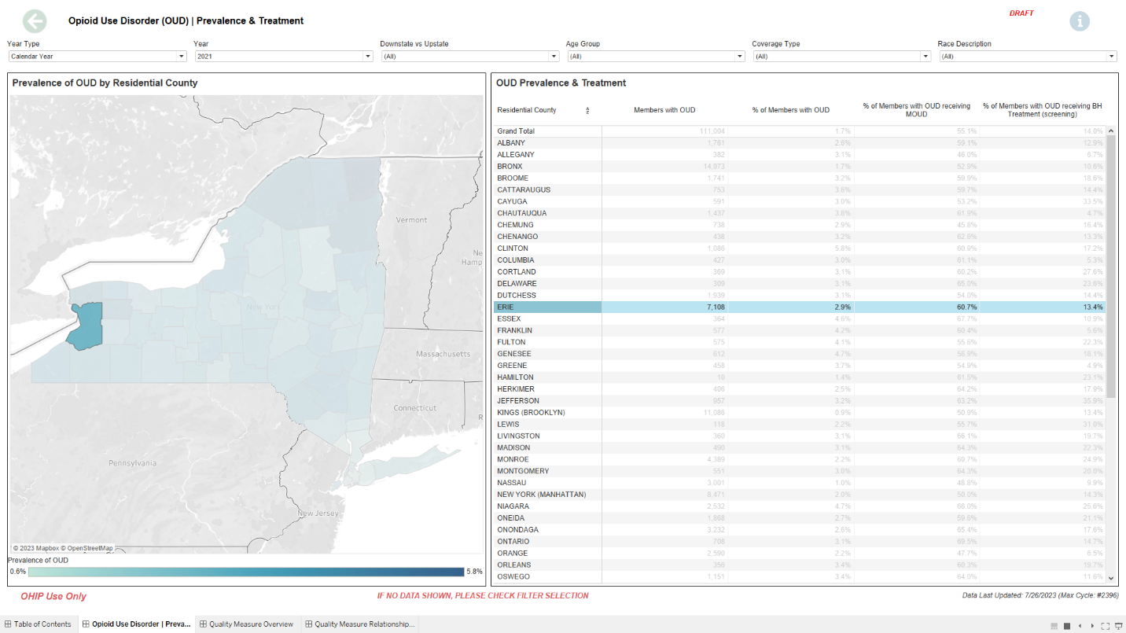

1. Alternatively, look at the tooltip which will show the number of members with an OUD Diagnosis
2. Look for Erie County in the table and look at the second column.
3. Use the Year Type Filter to switch to Calendar Year.
4. Use the Year Filter to switch to 2021.
5. In Federal Fiscal Year 2020, what is the percent of members with OUD receiving MOUD in Westchester County?

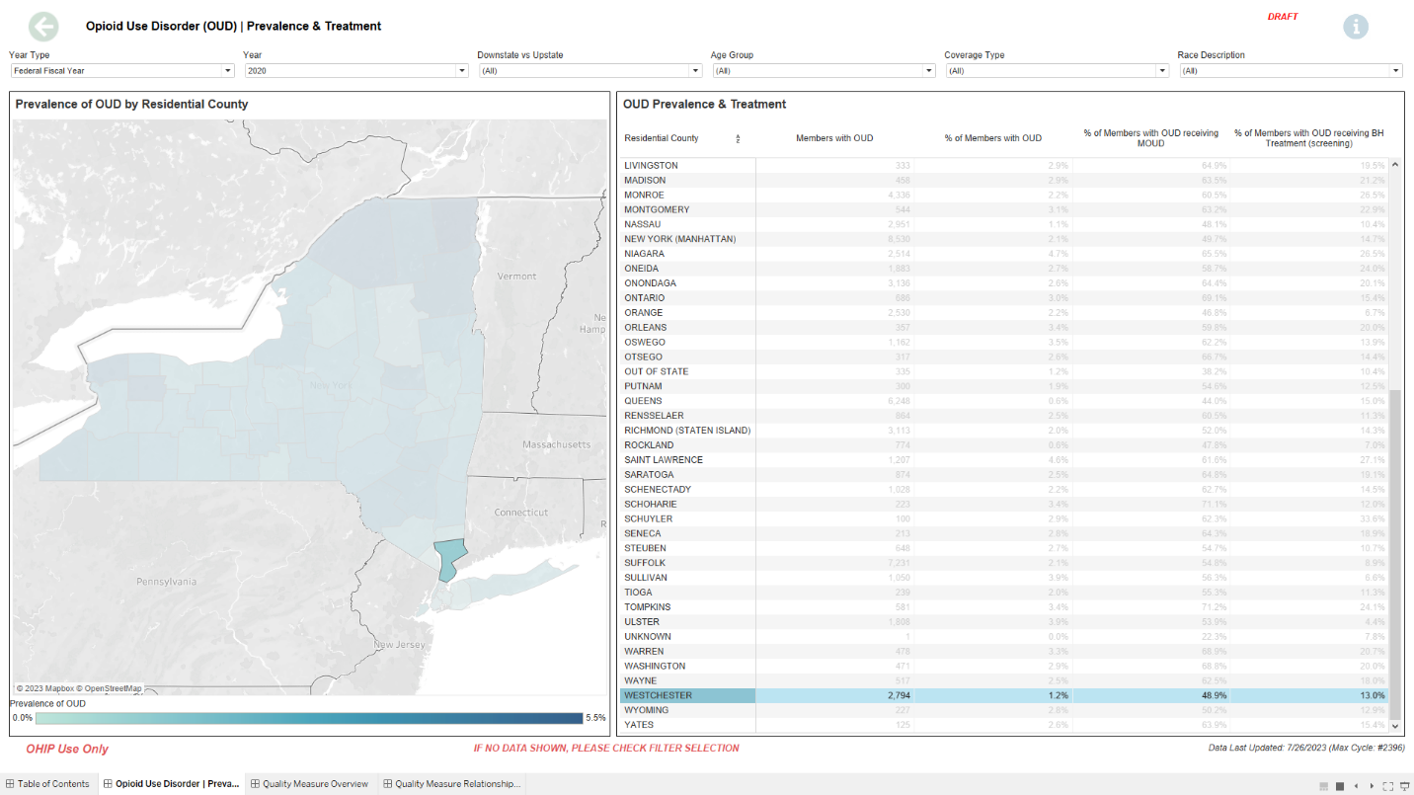

1. Find Westchester County in the table and look at the fourth column.
2. Use the Year Filter to switch to 2021.
3. Use the Year Type Filter to switch to Calendar Year.
4. In State Fiscal Year 2021, what is the percent of FFS members with OUD receiving Behavioral Health Treatment (screening) in Bronx County?

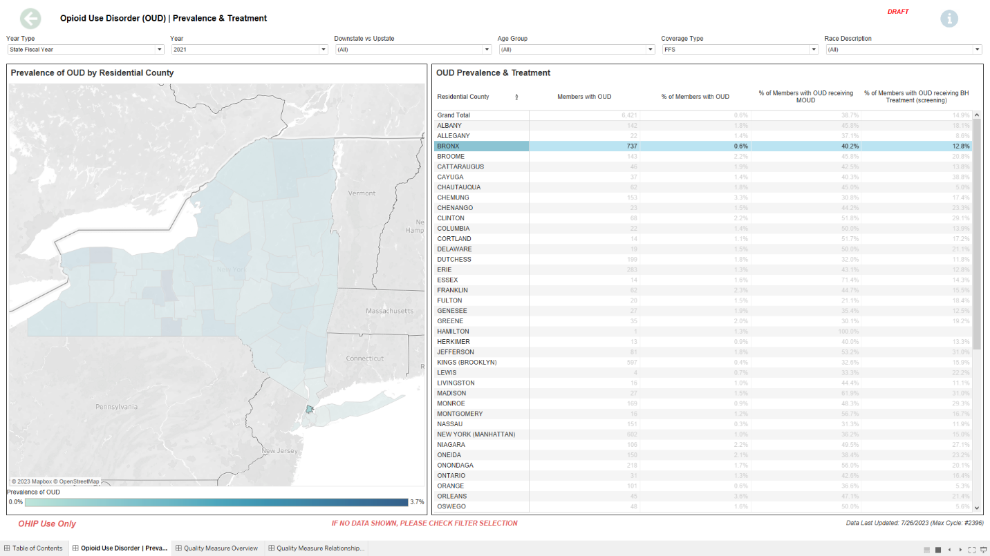

1. Find Bronx County in the table and look at the fifth column.
2. Use the Coverage Type Filter to select FFS.
3. Use the Year Filter to switch to 2021.
4. Use the Year Type Filter to switch to State Fiscal Year.
5. What is the trend by Coverage Type for Measure 2.6.6: Number of Individuals with OUD receiving behavioral health treatment (peer support) by State Fiscal Year?

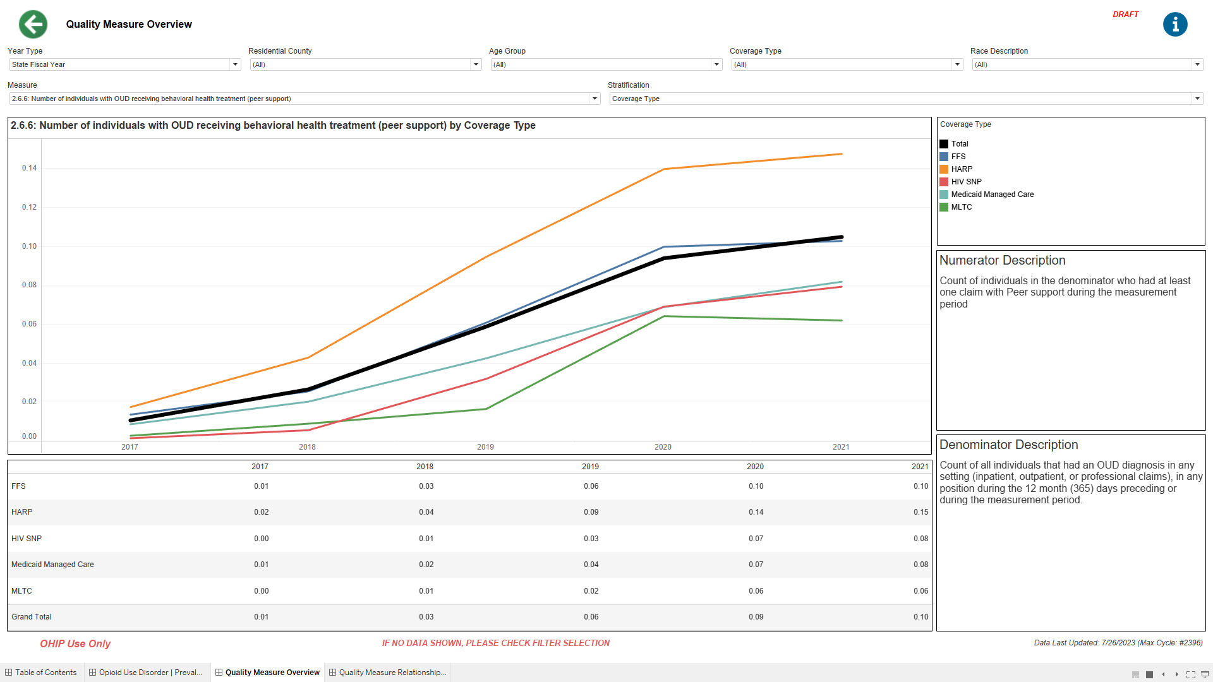

1. The line graph will show the trend of Measure 2.6.6 by Coverage Type for State Fiscal Year.
2. Use the Stratification Filter to switch to Coverage Type.
3. Use the Measure Selector to select Measure 2.6.6
4. Use the Year Type Filter to switch to State Fiscal Year.
5. What is the rate for Measure 4.6.3: Number of Opioid Related Oral Naltrexone Days Supplied for Asian or Pacific Islander Members in Calendar Year 2019?

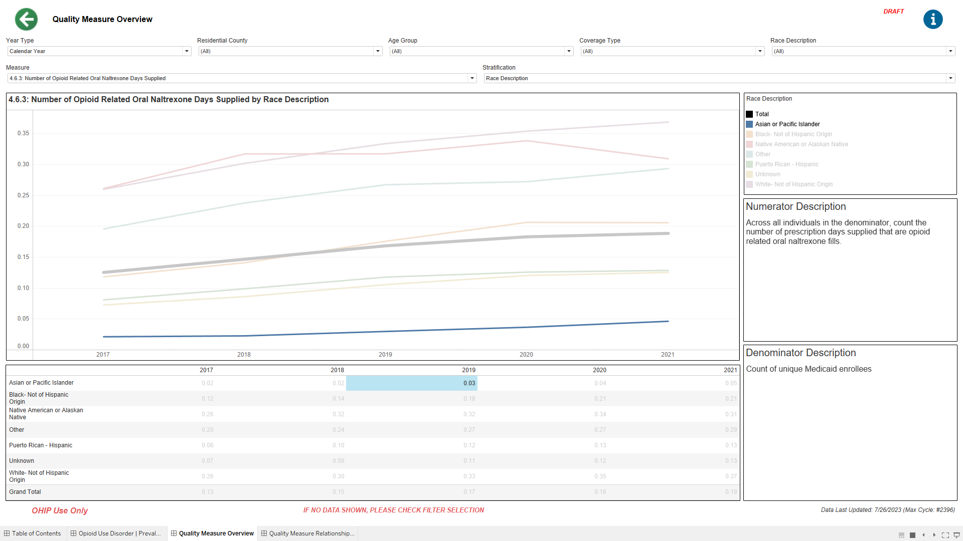

1. The table will give the rate for Measure 4.6.3 for Asian or Pacific Islander Members in 2019
2. Use the Year Type Filter to switch to Calendar Year.
3. Use the Measure Selector to select Measure 4.6.3
4. Use the Stratification Filter to switch to Race Description.
5. What is the general relationship between Measure 2.4 (Number of Individuals with Opioid Use Disorder (prevalence)) and Measure 2.5.5 (Number of Individuals with Opioid Use Disorder (OUD) Receiving buprenorphine products that are FDA approved for treatment of OUD) in Calendar Year 2021?
6. Use the X-Axis Measure Selector to select measure 2.4
7. Use the Year Type Filter to switch to Calendar Year.

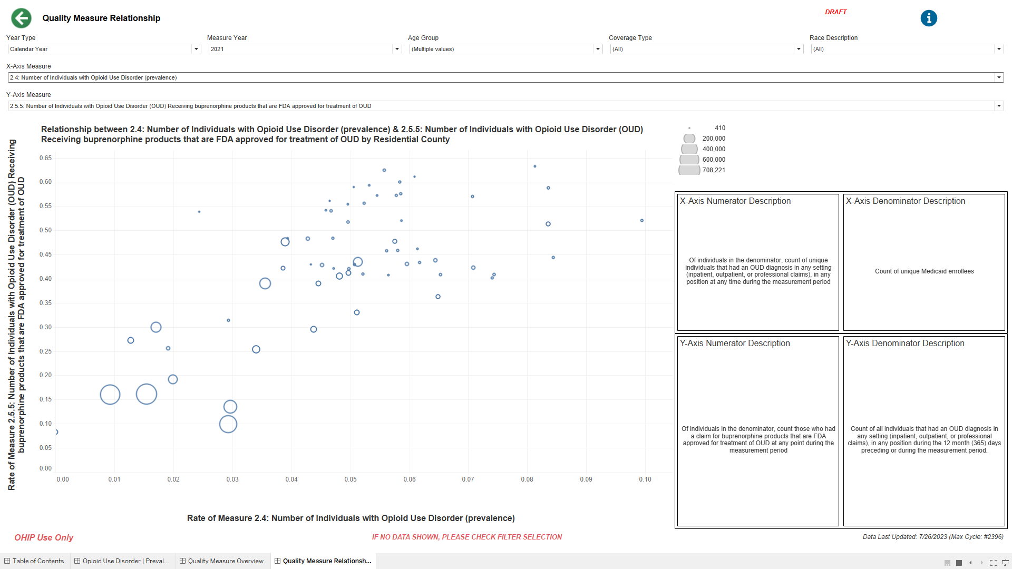

1. Use the Year Filter to select 2021.
2. The scatterplot on the left will show the relationship between measure 2.4 and measure 2.5.5
3. Use the Y-Axis Measure Selector to select measure 2.5.5
4. What is the general relationship between Measure 2.4 (Number of Individuals with Opioid Use Disorder (prevalence)) and Measure 2.5.2 (Number of Individuals with Opioid Use Disorder (OUD) Receiving Methadone) for members ages 18 and up in Calendar Year 2021?

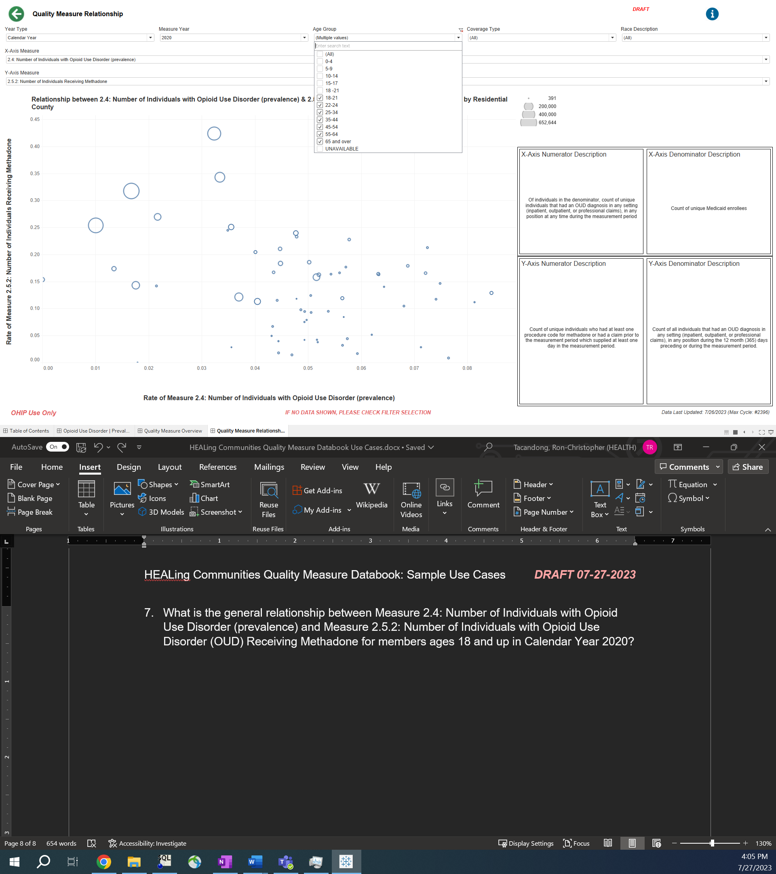

1. Use the Age Group Filter to only include ages above 18.
2. Use the Year Filter to switch 2021.
3. Use the Year Type Filter to switch to Calendar Year.

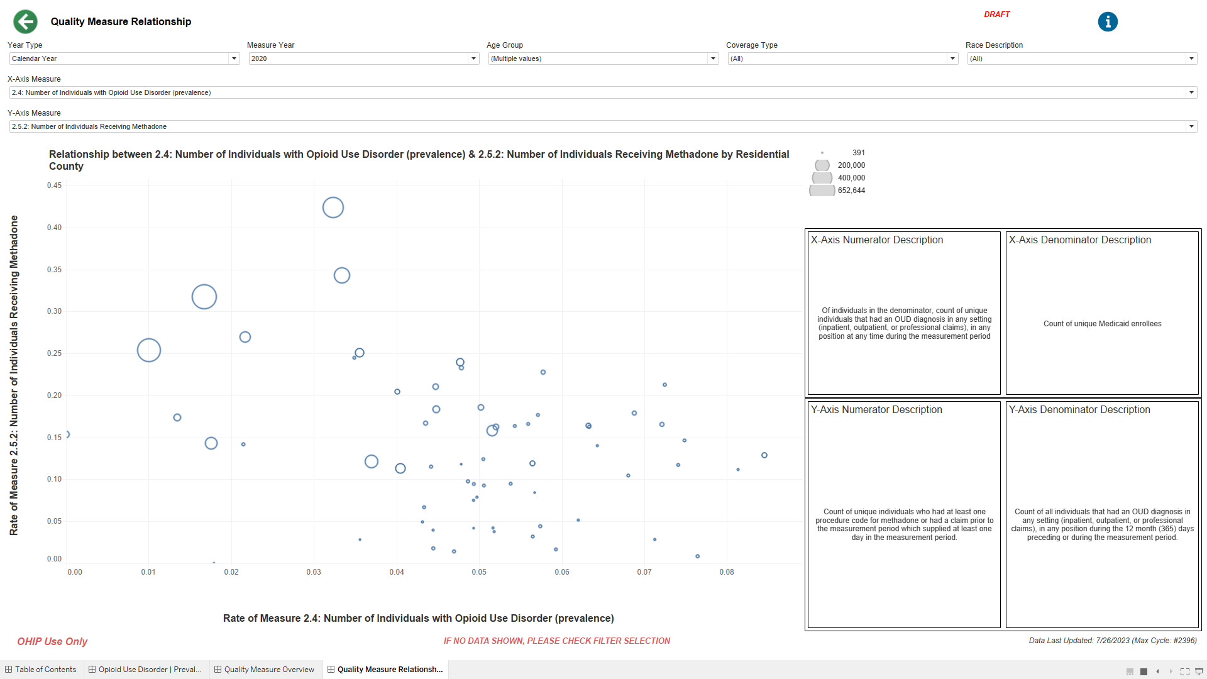

1. The scatterplot on the left will show the relationship between measure 2.4 and measure 2.5.2
2. Use the Y-Axis Measure Selector to select measure 2.5.2
3. Use the X-Axis Measure Selector to select measure 2.4